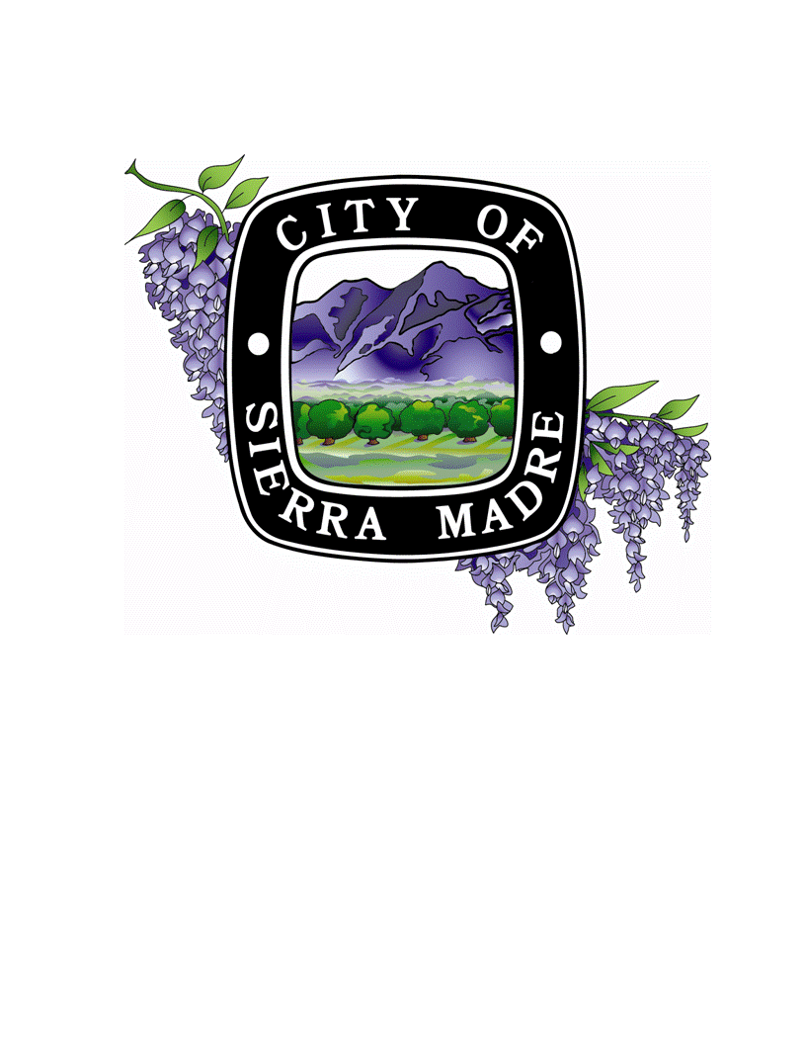
Library Board of Trustees

CITY HALL COUNCIL CHAMBERS
232 W. SIERRA MADRE BOULEVARD

PUBLIC NOTICE

THE SCHEDULED MEETING OF
Wednesday, April 25, 2018, AT 7:00 P.M.

IS CANCELLED

The Library Board of Trustees will resume their
regular meeting on Wednesday, May 23, 2018.

Questions: Contact the Library at (626) 355-7186

